Jira Lab Assignment 7

Harsh Rakeshkumar Bhatt

Project Management, Conestoga College

MGMT8750: Agile Project Management

Professor Shams Salim

July 18, 2023

Screenshot 1
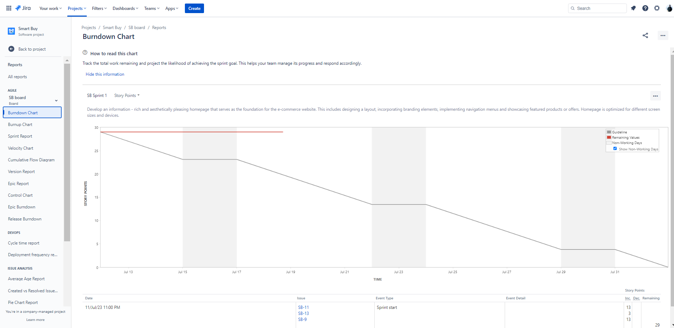

Screenshot 2

